# **Observing SSH & DHCP Traffic Using Wireshark & PowerShell in Windows VM**

## **Part 1: Observe ssh Traffic**

### **Step 1: Start VMs and Ensure they are Running**

* Open Azure and start VMs
* Open Microsoft Remote Desktop and login to your Windows VM

### **Step 2: Observe SSH Traffic**

* Open Wireshark.
* Begin packet capture on the appropriate Ethernet interface.

### **Step 3: Apply SSH Filter**

* In Wireshark’s filter bar, type:  
  ssh
* Press Enter to apply the filter.

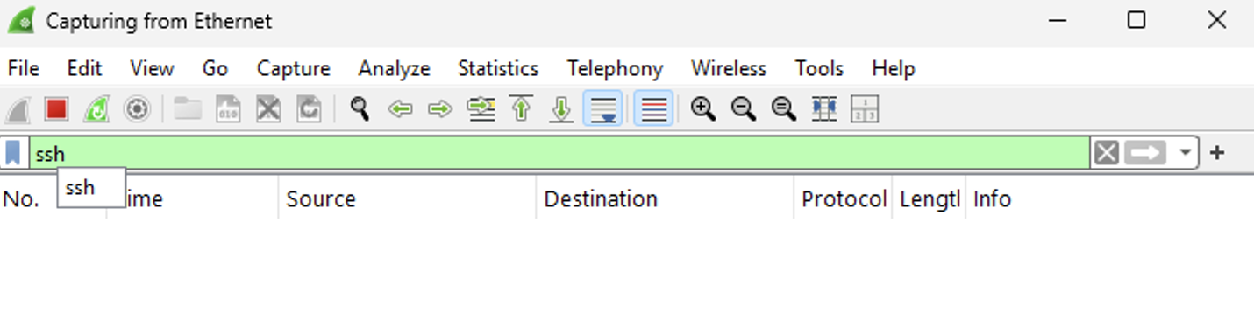

**Step 4: SSH into the Ubuntu VM**

* Open PowerShell as Administrator on the Windows VM.

Enter the SSH command:

ssh <username>@<Private IP Address>  
  
ssh labuser@10.0.0.5

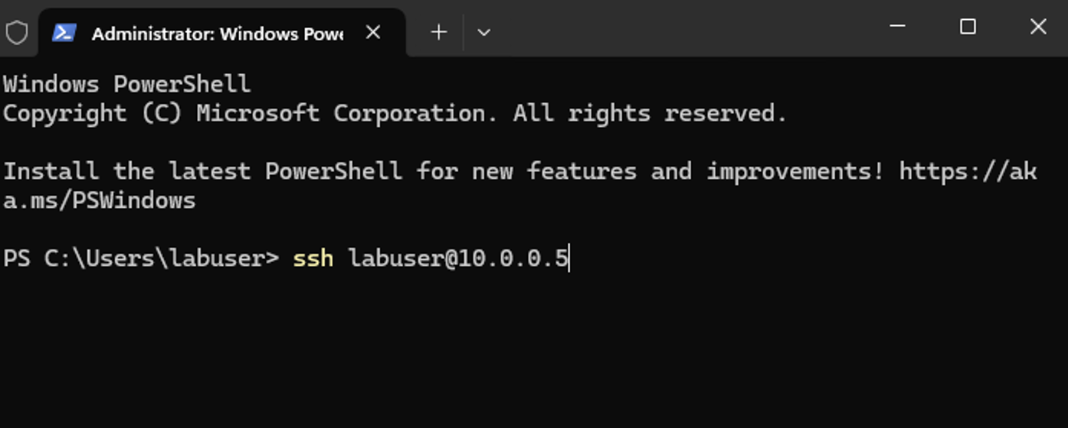

### **Step 5: Accept Host Key and Authenticate**

* When prompted, type yes to accept the fingerprint.
* Enter the password for labuser.
* Notice that with every entry there is ssh traffic.

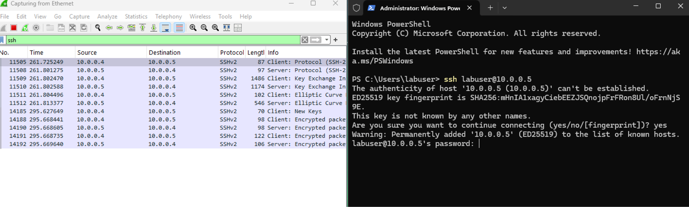

### 

### 

### 

### **Step 6: Observe ssh Traffic**

* Now that we are in the ubuntu vm we can begin to observe more ssh traffic.

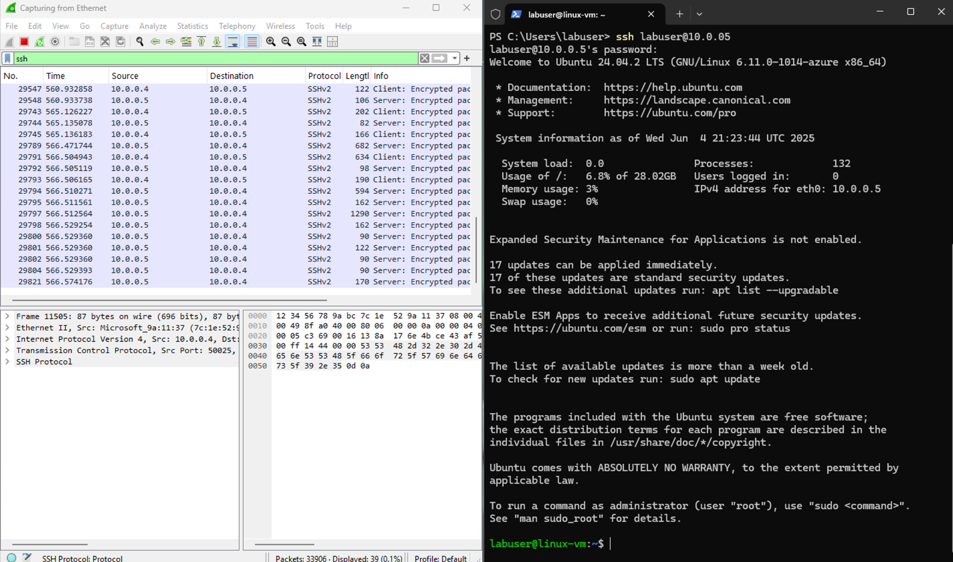

### **Step 7: Execute Linux Commands**

* Once connected to the Ubuntu VM, type the following:
* hostname
* id
* uname -a
* touch file.txt this will create a file
* Observe that with every key stroke there is ssh traffic

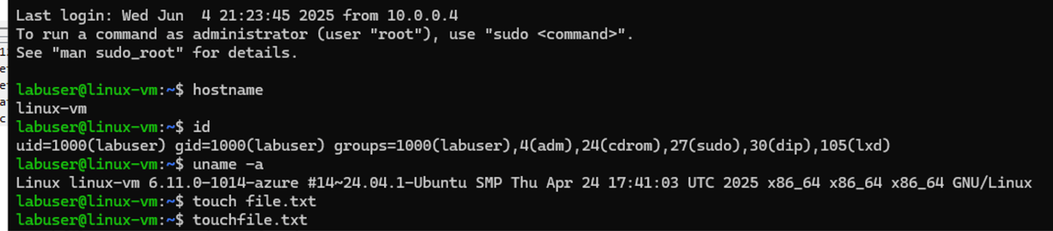

### 

### 

### **Step 8: Observe SSH Packet Activity in Wireshark**

* In the Wireshark filter type:  
  tcp.port == 22
* ssh uses TCP port 22
* Observe the live stream of encrypted packets during the SSH session.

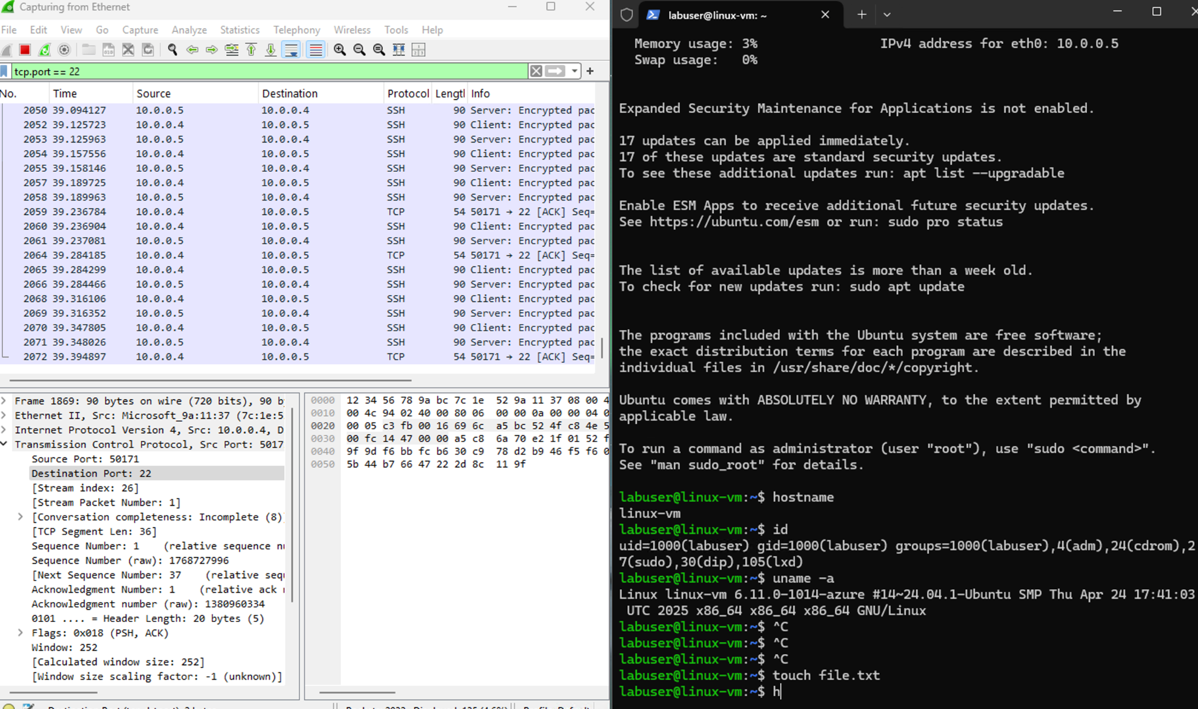

### **Step 9: Exit the SSH Session**

* In PowerShell type:  
  exit
* Confirm the session closes and SSH traffic stops.

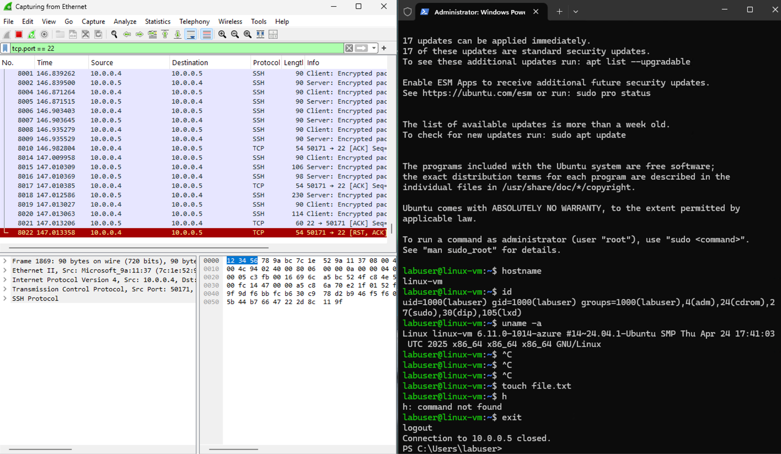

**Part 2: Observe DHCP Traffic**

### **Step 1: Filter for DHCP Traffic in Wireshark**

* In Wireshark’s filter bar, type:  
  dhcp
* Press Enter.

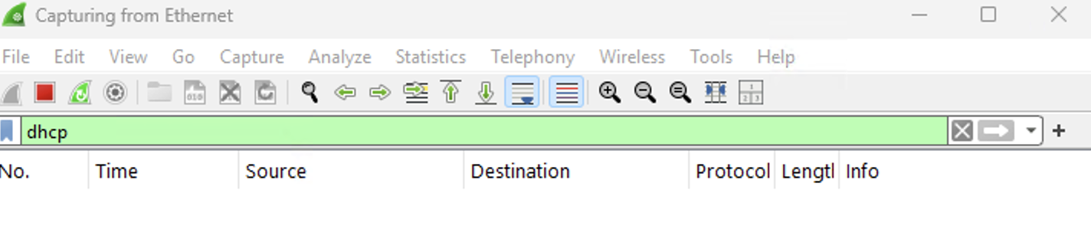

**Step 2: Release & Renew IP Address via PowerShell**

* Open PowerShell as Administrator.
* Run the following in PowerShell:

ipconfig /renew

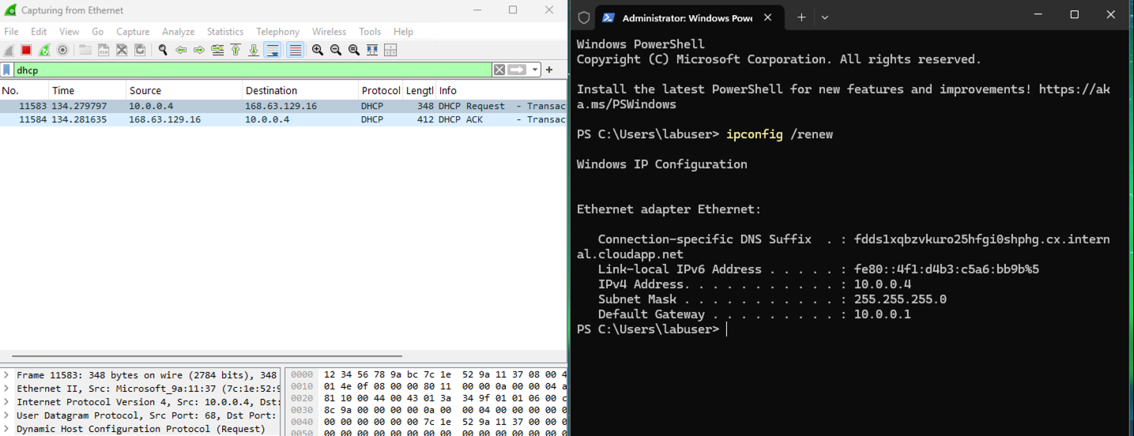

### 

### 

### 

### **Step 3: Automate IP Renewal with a Batch Script (Optional)**

* Open Notepad and type:  
  ipconfig /release

ipconfig /renew

* Save the file as: dhcp.bat
* Save it in: C:\ProgramData

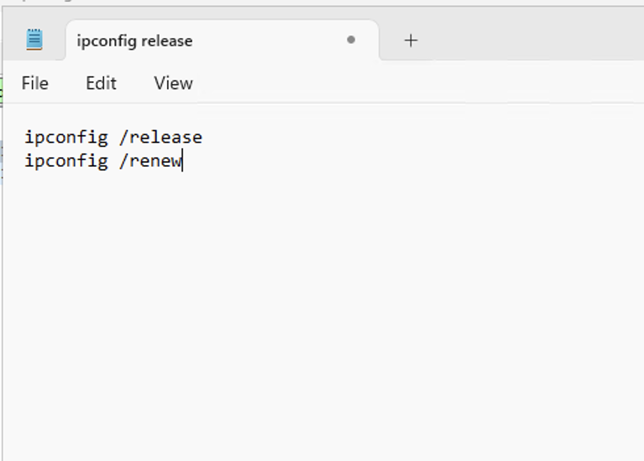

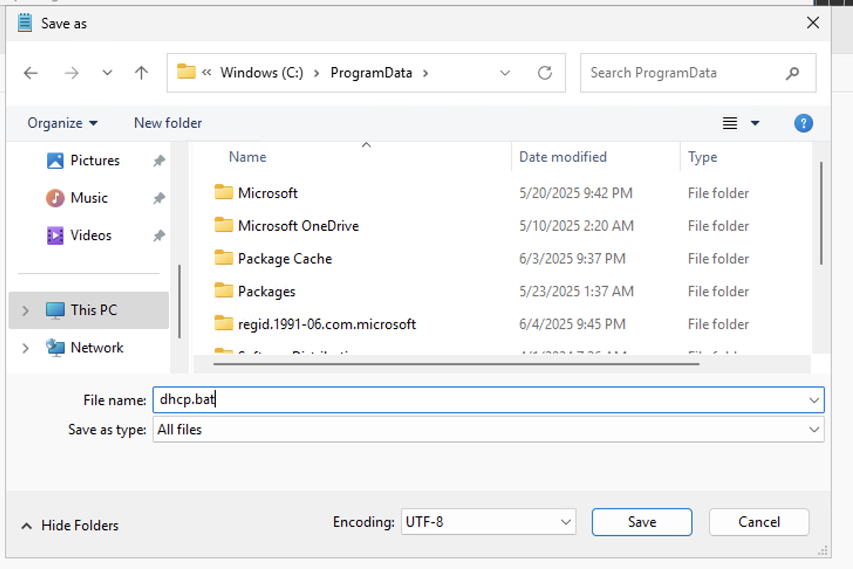

### 

### 

### 

### **Step 4: Navigate to Batch Script Location**

* In PowerShell type:  
  cd C:\ProgramData
* ls

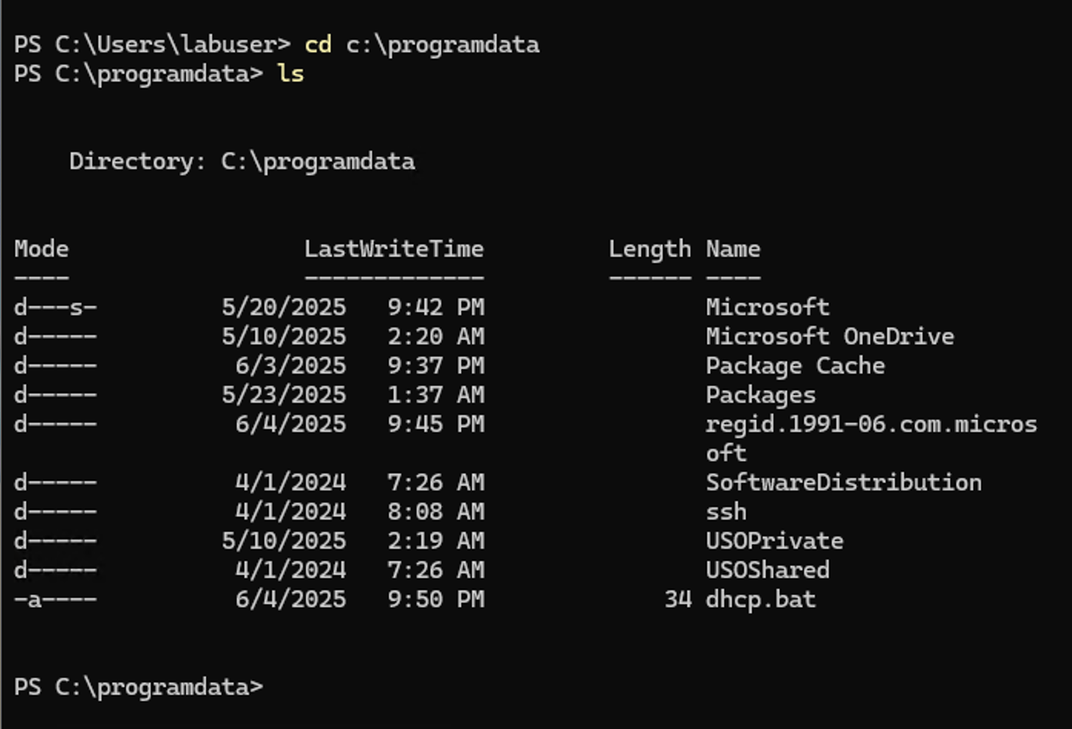

### **Step 5: Run the Script to Trigger DHCP Events**

* Execute the script in PowerShell:  
  .\dhcp.bat

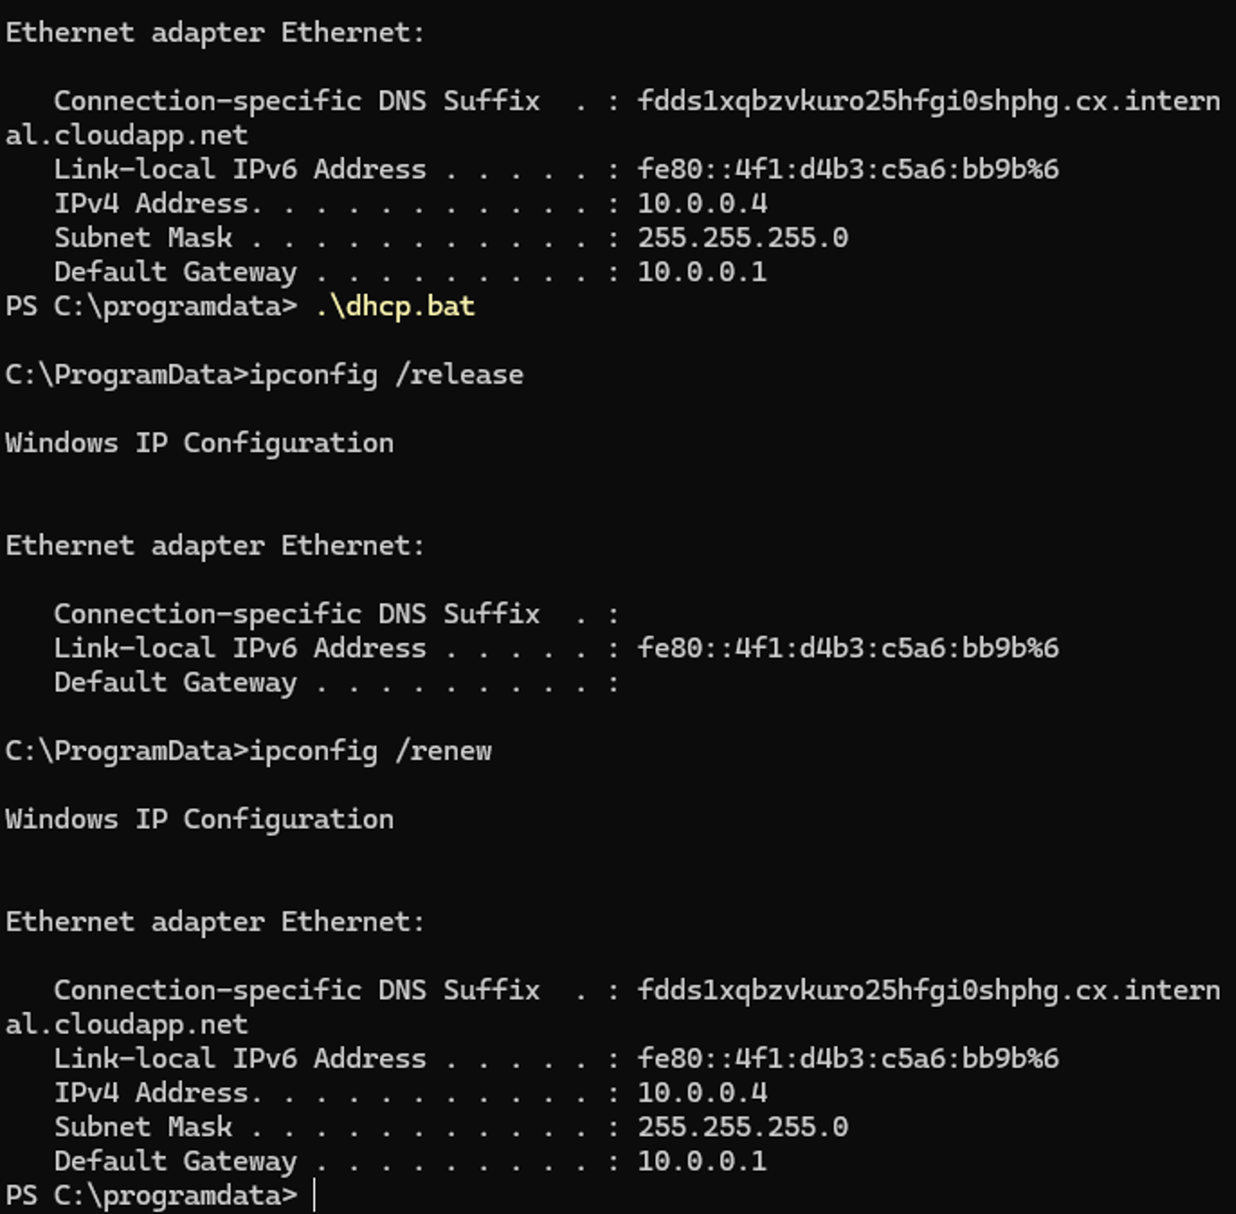

**Step 6: Observe DHCP Traffic in Wireshark**

* In Wireshark, observe the following:
  + **DHCP Discover**
  + **DHCP Offer**
  + **DHCP Request**
  + **DHCP ACK**

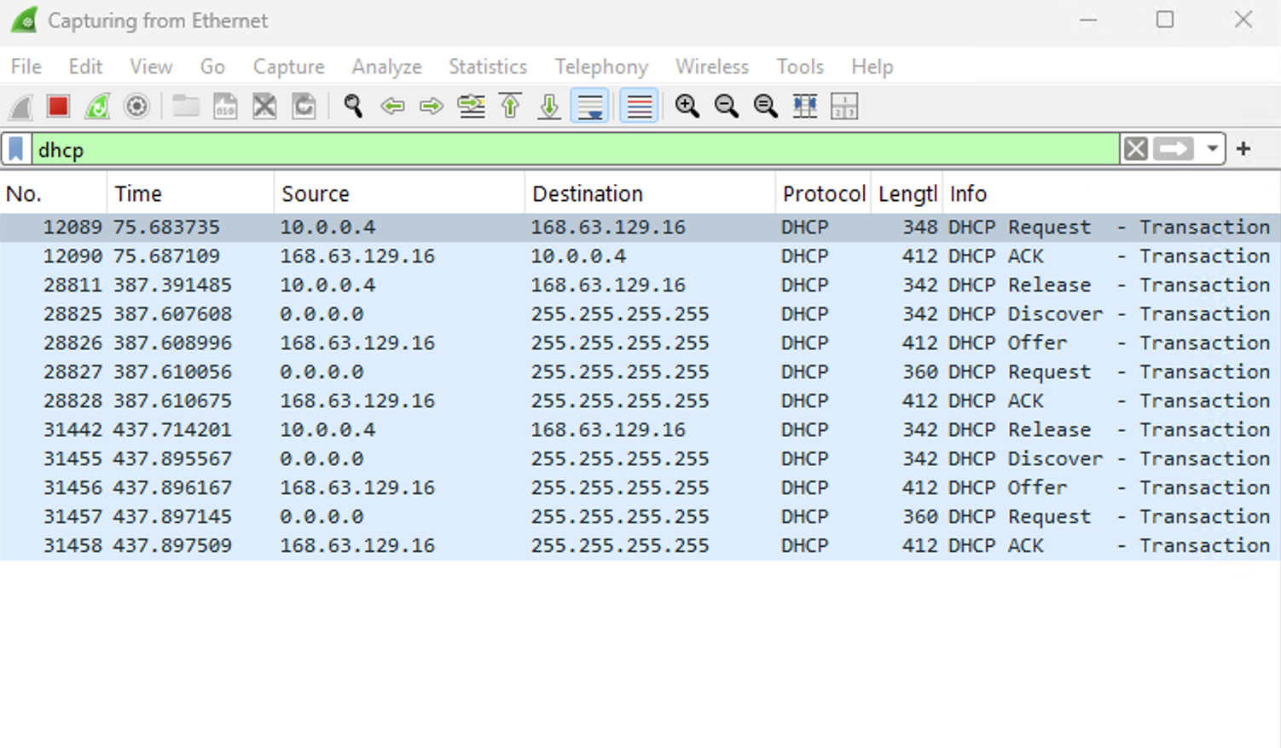

### **Step 7: Handle Temporary Disconnection**

* If connection drops briefly after IP release, you may see a message like:

